**Multiple spawning events promote increased larval dispersal in a western boundary current.**

Schilling, Everett, van Sebille (?), Smith, Stewart, Hughes, Roughan (?), Kerry, Suthers

**Abstract**

Transport of larvae by ocean currents to appropriate juvenile habitat is an important mechanism for many marine species. Changes in the spawning timing or location can have large implications on the final destinations of ocean transported larvae. A previously unrecognised late summer spawning event was reported for the southwest Pacific population of *Pomatomus saltatrix*. While fishing restrictions are in place to protect the traditionally recognised spring spawning events, the importance of this new spawning event is uncertain. Here we conduct a particle tracking simulation of *P. saltatrix* spawning and resulting larval dispersal via the East Australian Current to highlight the differing contributions of the spawning events to potential settlement along the east Australian coast. By modelling the three recognised spawning events, we show that the newly recognised late summer spawning event contributes the highest proportion of larvae to the southern portion of the distribution. This is due to reduced mortality (due to faster growth in the warmer water) and the seasonal strengthening of the East Australian Current driving particles further south. Spawning over broad temporal and spatial scales by *P. saltatrix* has potentially developed as a mechanism to ensure maximum dispersal of larvae.This finding demonstrates that species which utilise ocean currents for transport of larvae can substantially alter the final settlement locations of larvae by spawning in different locations or at different times of the year.

Keywords: particle tracking, tailor, bluefish, *Pomatomus saltatrix*, connectivity, larval transport

**Introduction**

The larval phase of many marine organisms is subject to extremely high mortality (from both predation and starvation), with large numbers of larvae often being spawned to overcome this (Pepin, 1989). Ocean currents then transport larvae away from the spawning sites, potentially to juvenile habitat. This dispersal can result in larvae potentially settling up to 100’s of kilometres away from the original spawning site (Cetina-Heredia et al., 2019, Cowen et al., 2006). Both seasonal and fine scale temporal variation in ocean currents can result is vastly different larval distributions, potentially contributing to the highly variable recruitment (Houde, 1989b, Siegel et al., 2008). Many species use this variation by spawning at specific times of the year in specific locations, potentially as an adaptation to maximise larval survival, by potentially spawning in areas with more favourable oceanography (Davies et al., 2014, Cowen and Sponaugle, 2009). It is important that the transport potentially settlement of larvae from spawning events is understood to in order to understand the connectivity between spawning and settlement locations, a key component of the reproductive cycle.

With advances in computing power and higher resolution ocean models, biophysical models parameterised with species specific information are increasingly being used to understand and manage connectivity in the marine environment (Gallego et al., 2007, Hinrichsen et al., 2011). By tracking particles, it possible to identify particularly important areas for larval production in terms of transport to suitable juvenile habitats (Everett et al., 2017, Munroe et al., 2018). High resolution hydrodynamic models provide a mechanism to examine the physical factors which shape observed distributions of larvae and settled juveniles. More than 500 biophysical models have been successfully applied in many systems (Nolasco et al., 2018), including the Southern Ocean (Fraser et al., 2018), coastal boundary currents (Everett et al., 2017) and seas such as the Mediterranean Sea (Andrello et al., 2013). These models have provided insight into transport mechanisms for a variety of organisms including kelp (Coleman et al., 2011, Fraser et al., 2018), invertebrates (Everett et al., 2017, Munroe et al., 2018) and fish (Santos et al., 2018, Paris et al., 2005).

*Pomatomus saltatrix* is a globally important recreational and commercial fish species (Juanes et al., 1996). As a coastal pelagic predator with well documented annual migrations to spawning grounds in a boundary current system, *P. saltatrix* is a good candidate for the use of particle tracking models to investigate larval dispersal from the spawning regions. In the Atlantic Ocean, previous research used hydrography, wind and satellite derived temperature to investigate larval transport processes of *P. saltatrix* and found that the number of juveniles recruiting to estuaries is highly likely to be driven by oceanographic features (Hare and Cowen, 1996). In the southwest Pacific Ocean, *P. saltatrix* (locally known as tailor) undertake annual migrations along the east coast of Australia approximately tracking with sea surface temperature (abundance peaks at 21.5°C) (Brodie et al., 2018). In winter, *P saltatrix* migrates north, up to 26°S (Fraser Island) where in spring the main spawning event occurs (Zeller et al., 1996, Pollock, 1984), and then over summer and autumn they return south, along the east coast of Australia (Brodie et al., 2018). This spawning event at Fraser Island is well documented and has resulted in a seasonal closure (August – September) of fishing to protect the species (Leigh et al., 2017). Recently it was shown that the spring spawning event extends south to 30°S and a previously unrecognised spawning event occurs between 28°S and 30°S during late summer (Schilling et al., 2019). It is important that the implications of this spatially larger spring spawning and ‘new’ late summer spawning event are understood in terms of potential larval dispersal and settlement in comparison with the traditional spawning event at Fraser Island.

The overall goal of this study was to use an oceanographic particle tracking model to investigate dispersal of *P. saltatrix* larvae in eastern Australia, utilising the recently recognised spawning times and locations. Specifically, this study aims to 1. Use forward simulations to compare potential settlement of larvae at different latitudes along eastern Australia from the different spawning events, and 2. Use a backward simulation to investigate if observed locations of juvenile *P. saltatrix* can be explained by the recently recognised spawning events.

**Methods**

*Oceanographic model details*

To investigate oceanographic larval dispersal from the identified spawning periods, a particle tracking simulation was run using PARCELS (Lange and van Sebille, 2017, Delandmeter and van Sebille, 2019). This simulation used the velocity fields from an east Australian Regional Oceanographic Model (ROMS; Kerry et al., 2016). The model domain extends from Fraser Island in the north (25.12°S) to south of the NSW/Victoria border (41.55°S) and approximately 1000m offshore (162.22°E), encompassing the EAC system from where it is most coherent to where it separates from the coast and forms an energetic eddy field in the Tasman Sea. The model is eddy resolving, has a 2.5-5km cross-shore resolution and a 5km alongshore resolution, with 30 vertical s-levels. The model simulation covers a 22-year period (1994 – 2016) and has a similar configuration to the 10-year simulation described in Kerry et al. (2016). Although the ROMS simulation is free running, as it is nested within the most recent BlueLink Reanalysis (BRAN3p5; Oke et al., 2013) its boundaries are constrained by observations.

*Particle characteristics*

The model was run using only surface velocities as *P. saltatrix* larvae are found almost exclusively at the surface in this region (Miskiewicz et al., 1996). The paths of each particle were interpolated using 5min steps based upon the velocity fields from the ROMS model. Each particle included a small Brownian motion walk function which added natural variation to the movement of each particle and ensured no two particles followed the exact same path.

As larval growth rates are highly temperature dependant (Houde, 1989a, Green and Fisher, 2004), the duration of tracking for each particle (settlement time) was temperature dependant and estimated using degree-days (DD; thermal constant; Neuheimer and Taggart, 2007). With this approach, each particle is assumed to settle when the cumulative sum of daily temperatures experienced by that particle reaches the thermal constant (Everett et al., 2017). Larval growth in *P. saltatrix* has been shown to be both temperature and size dependant with larvae growing faster in both warmer waters and at larger sizes, resulting in an exponential growth curve in the larval size range (Hare and Cowen, 1997, Hare and Cowen, 1995). Growth and temperature data were combined from various sources to estimate a thermal constant for various stages of development. Larvae (2.1mm) hatch from eggs at 39 DD (Deuel et al., 1966), growth from the yolk sack occurs at a rate of 0.039 °C/day until 2.9mm (59.3 DD; Deuel et al., 1966), at which point the growth rate growth changes to 0.003 mm/°C/day which results in an exponential shaped curve with our specified settlement occurring at 500 DD (10.7 mm). This growth rate closely matches observed growth rates in larval *P. saltatrix* (Juanes et al., 1996, Hare and Cowen, 1995). For a water temp of 22°C, this means larvae will settle after 23 days which matches the observed transition from larvae to juvenile in this species (Hare and Cowen, 1994). A settlement time of 500 DD (10.7 mm) was used as it is just before the transition from larvae to juvenile whereby swimming would become vastly more important than passive drift from ocean currents (Neira et al., 1998, Hare and Cowen, 1994, Hare and Cowen, 1996).

Larval mortality was incorporated into this model by releasing many particles and applying a daily mortality rate to each cohort of particles. As mortality is a daily constant for each cohort, the number of particles dying each day is constant between cohorts until particles reach the settlement time. Therefore to save computing time and reduce the number of starting particles we needed to model, we only applied mortality from day 16 onwards (prior to any settlement). As the actual larval mortality rate of *P. saltatrix* in this region is unknown we applied an instantaneous mortality rate (*M*) of 0.25, which is equivalent to a 22.12 % actual daily mortality rate. This value was selected as it is the approximate mean *M* and appropriate for the temperatures observed in this region (Houde, 1989a). While this value may not be accurate, applying a daily mortality rate in conjunction with the growth specified in degree days allows us to model the effect of increased cumulative mortality on larvae which spend longer in the water column (and therefore more vulnerable to predation) before settlement.

*Forward simulation of observed spawning events*

Using the results of a reproductive biology survey reported in Schilling et al. (2019), the particle release locations and months were specified to simulate the observed spawning periods. Three spawning events were modelled, A spring QLD (26 – 27.5°S release locations) spawning event, a spring NSW (28.5 – 30°S) spawning event and a late summer NSW (28.5 – 30°S) spawning event (Figure 1). The spring spawning event spanned August – December inclusive and the late summer spawning event combined February and March releases. Within these release locations particles were released every 0.5° latitude on the 100m isobath to encompass all locations *P. saltatrix* in spawning condition was observed. As no data is available on relative spawning biomass at different locations or times, we assumed a constant daily spawning rate at all locations. A cohort of 1000 particles were released from each location every day (during the spawning months) for 22 years (the duration of the ROMS model).

*Backward simulations from locations of observed juvenile P. saltatrix*

Backwards simulations were run using the same particle characteristics, except mortality was not incorporated as we know the settlement locations of the particles and are only interested in the potential spawning locations that could have resulted in transport to these locations. Locations were determined by consulting literature and observations of where juvenile tailor are encountered (Leigh et al., 2017, Schilling et al., 2018, Schilling, 2019). As the east Australian Current dominates the region, we did not simulate any backwards tracking releases north of 31S as the majority of the particles were estimated to leave the northern boundary of the ROMS model (which corresponds to the most northern spawning for this population). Release locations are detailed in Table 1. A cohort of 100 particles was released per location every 7 days for 22-years on the 100m isobath. These particles were subset to only include those which were predicted to have spawned during the spawning months (August – December, February or March).

*Data analysis*

Larval distributions from each particle tracking simulation were mapped using to show the positions of all particles at 500 DD. Settlement from each spawning event was quantified by finding the percentage of particles which successfully settled (final location on the continental shelf) in 1° latitude bins. Larvae which were not on the continental shelf (≤ 200m depth) at settlement (500 DD) were considered as mortalities in the analysis. As swimming is not included in the model, estimates of survival are conservative with actual survival likely to be higher due to shoreward swimming (Hare and Cowen, 1996). Therefore, the estimates presented are conservative lower estimates of settlement but likely fully represent latitudinal transport distance.

**Results**

*Settlement time*

The number of days which it took larvae to reach settlement (500 DD) varied between the three spawning events (Figure 2). Using all particles which reached 500 DD, the mean settlement days were Spring QLD 22.5 days, Spring NSW 23.2 days and Summer NSW 20.8 days. For only larvae which settled on the continental shelf the means varied slightly but a similar pattern emerged, Spring QLD 22.4 days, Spring NSW 23.5 days and Summer NSW 21.1 days.

*Dispersal from spawning events*

The larval dispersal simulated by the particle tracking model was almost exclusively southward except for 0.09 % of particles from the southern QLD release which finished north of 26°S (Figure 3, Table 3). A high proportion of particles in each spawning period were dispersed offshore, particularly south of the separation zone where the East Australian Current separates from the Australian mainland (Figure 2, Table 2). The spring NSW release had a particularly low number of larvae reach 500 DD on the shelf (0.227 %) compared to 0.753 % and 0.96 % respectively for the Spring QLD and Summer NSW spawning events.

While both the Spring QLD and Summer NSW spawning events had areas of high settlement density (near the spawning locations), the Spring NSW spawning event had a wider dispersal of particles with no high density areas of settlement (Figure 3). The late summer NSW spawning event extended the furthest south with moderate dispersal offshore (Figure 3).

When the contribution of each spawning event was investigated by settlement latitude, it showed that the 3 spawning events are disproportionately important for different latitudes of eastern Australia. The Spring QLD spawning event supplied all larvae settling north of 28°S but the proportion of particles settling in each 1° latitudinal bin from the Spring QLD spawning decreased as latitude increased. The Spring NSW spawning event contributed a small proportion of particles settling between 28 and 30°S but contributed between about 15 and 30 % for all latitudes south of 30°S. The NSW summer spawning event contributed the large proportions (30 – 60 %) of the larvae which settled south of 29°S with this spawning event contributing over 50% of the larvae settling south of 37°S.

*Backward tracking*

The backwards simulation of all larvae released at known locations where juveniles are found revealed that the most likely spawning sites were consistently along the coast, to the north of the release sites (Figures 5 &6). The coastal affiliation was particularly strong for the spring spawning events with the high density areas of likely spawning locations almost exclusively found along the continental shelf (Figure 5). The exception was for juveniles from Gippsland Lakes (the most southern site) which had a higher proportion of offshore potential spawning locations (Figure 5). For the late summer spawning event there was a much broader distribution of potential spawning sites, although northern coastal spawning locations still showed the highest density of potential spawning locations (Figure 6).

**Discussion**

This study simulated larval dispersal from the three recognised spawning events for *P. saltatrix* in the southwest Pacific and highlighted the varying importance of the spawning events to settlement along the east Australian coast. The spring QLD spawning event supplied the majority of the settling larvae in the north of the distribution while the late summer NSW spawning event had a higher proportion of larvae reaching the southern portion of the species distribution compared to spring spawned larvae from both NSW and QLD. This study shows how reproductive biology knowledge can be combined with particle tracking models to better understand the importance of spawning events to larval supply.

*Settlement times*

The use of degree days to model temperature dependant growth rates and therefore settlement times resulted in substantial differences between the three spawning events in terms of settlement times and mortality. For larvae settling in a suitable location (on the continental shelf), the summer NSW spawning event had settled on average a day earlier than the spring QLD spawning event and 2 days earlier than the spring NSW spawning event. This means that both the NSW and QLD spring spawning events were subject to increased mortality as they were vulnerable to predation for longer. This was reflected in the percentage survival and percentage settlement of the three spawning periods with the summer NSW having almost double the survival percentage of the spring NSW spawning event. Without the use of temperature dependant growth rates, the settlement day would not have varied between spawning events and therefore the daily mortality rate would not have produced any differences in survival. This would have resulted in the spring NSW spawning event being potentially over represented in the final larval survival and settlement numbers. Degree days have been used successfully before in particle tracking models (Everett et al., 2017) and our findings confirm that when available, temperature dependant growth (and settlement times) should be included in particle tracking models to account for faster growth and earlier settlement occurring in warmer waters (Neuheimer and Taggart, 2007, Houde, 1989a).

*Larval dispersal*

The forward tracking models revealed that the spring QLD spawning event is highly important for overall population recruitment. Assuming a constant rate of spawning (day-1), this spawning event has the largest number of larvae which settle on the continental shelf and therefore more likely to find suitable habitat and survive. On the other hand, both NSW spawning events are important for recruitment in the southern portion of the species distribution with both spring and late summer NSW spawning events having higher contributions to settlement south of 34°S than the spring QLD spawning. The late summer NSW spawning event had the highest proportion of particles which settled south of 30°S with the influence of this spawning event increasing with latitude. It is likely the two NSW spawning events drive recruitment in the southern Australian state of Victoria (south of 37°S), where commercial catch of *P. saltatrix* is small and often variable (Litherland et al., 2016). A further analysis of interannual variability and larval dispersal may provide more insight into the drivers of recruitment for the most southern portion of the population.

The spring QLD spawning event had large numbers of larvae which settled north of the East Australian Current (EAC) separation zone (~32°S) before they could be advected offshore. These northern particles were often driven by onshore currents which resulted in low velocities and short distances travelled due to interactions with the land. The greater offshore dispersal evident in both NSW spawning events was driven by the separation zone where the EAC separates from the Australian coast. The results of this are seen in the concentrations of particles which ended up offshore, approximately 33 – 35°S. This could be further examined using the paths of individual particles which get advected offshore and entrained into eddies. These eddies are highly common along the east coast of Australia and particularly strong south of the EAC separation zone (Everett et al., 2012, Suthers et al., 2011). Climate change is driving change in the EAC region with the flow strengthening up to 35 % (Sun et al., 2012), and separation occurring further south (Cetina-Heredia et al., 2014), which will likely result in increased larvae being dispersed offshore This has large implications for the larval transport of many species, including *P. saltatrix* which utilise this western boundary current for dispersal. Increased dispersal of many species if already being observed with the tropicalisation of temperate regions as tropical fish larvae are transported further south (Vergés et al., 2014).

The backwards simulations from locations where juvenile *P. saltatrix* are found showed that the three identified spawning events have the potential to supply larvae to all locations. The most southern release site (Gippsland Lakes, 38°S) had lowest likelihood of larvae being spawned in the identified spawning region (north of 30°S) and this is likely why the recruitment of *P. saltatrix* to this southern region is highly variable (Leigh et al., 2017), with larvae not being consistently transported this far south. All other sites for the backwards tracking showed very high likelihood that the larvae were spawned in the spawning region and this corresponding to the regular observed annual recruitment. All backwards tracking models were showed a high likelihood of spawning along the coast (particularly north of 33°S), which highlights the fact that the EAC is the dominant coastal current with few currents delivering water from the more easterly ocean onto the continental shelf.

The differing larval dispersal from multiple spawning events for *P. saltatrix* in this region likely reflects adaptation by this population to maximise fitness and larval recruitment to a wide area of coastline as suggested in Schilling et al. (2019). Having multiple spawning events spread over space and time, resulting in different larval dispersal patterns has been observed in other species of fish and invertebrates and suggests that this may be a reliable way of ensuring that larvae have the opportunity to recruit to suitable habitat over a wide region (Davies et al., 2014, Lambert and Ware, 1984).

*Conclusion*

This paper has shown that by spawning in different areas and times of the year, broadcast spawning species such as *P. saltatrix* can substantially alter the final settlement locations of larvae. We have demonstrated that dispersal of larval *P. saltatrix* along the east coast of Australia is dependent on the multiple spawning events which contribute varying proportions of larvae along the coast. The late summer spawning event is particularly important for settlement in the southern portion of the distribution. Future work may further consider the changes that are occurring to ocean currents with climate change and how this may alter the larval transport of marine fish.

*Acknowledgements*

This work was funded by an Australian Research Council Linkage Project (LP150100923) and the NSW Recreational Fishing Trust. This research includes computations using the Linux computational cluster Katana supported by the Faculty of Science, UNSW Australia. Thanks to John Morrongiello and Francis Juanes who made useful comments on the thesis chapter which was the basis of this paper.

**Tables**

**Table 1** Site details for the particle tracking simulations. Both forwards and backwards simulations were done from the specified latitudes. Forward tracking locations were based upon documented spawning events (Schilling et al., 2019). Backwards tracking locations were based on estuaries were juvenile *P. saltatrix* have been observed. All simulations were started on the 100 m isobath.

|  |  |  |
| --- | --- | --- |
| **Location** | **Latitude (°S)** | **Forward or Backwards Tracking** |
| Southern QLD | 26, 26.5, 27, 27.5 | Forwards |
| Northern NSW | 28.5, 29, 29.5, 30 | Forwards |
| Hastings River | 31.4 | Backwards |
| Wallis Lake | 32 | Backwards |
| Sydney Harbour | 33.8 | Backwards |
| Jervis Bay | 35.1 | Backwards |
| Wagonga Inlet | 36.2 | Backwards |
| Twofold Bay | 37 | Backwards |
| Gippsland Lakes | 38 | Backwards |

**Table 2**

Details of the forward tracking particles. As mortality was only modelled from the day prior to any settlement occurring (day 16), the effective number of released larvae is the number of released larvae which would be equivalent to applying mortality the whole time period and having the actual number of released larvae when mortality started to apply. The percentages were calculated on the effective number of larvae to be more accurate.

|  |  |  |  |  |  |  |
| --- | --- | --- | --- | --- | --- | --- |
| **Spawning event** | **Larvae released in model (#)** | **Effective number of released larvae (#)** | **Larvae surviving to 500 DD (#)** | **Percent survival to 500 DD** | **Larvae settled on shelf (#)** | **Percent settlement on shelf (%)** |
| Spring QLD | 3,366,000 | 111,466,577 | 1,876,658 | 1.684 | 839,376 | 0.753 |
| Spring NSW | 3,366,000 | 111,466,577 | 1,538,584 | 1.380 | 253,234 | 0.227 |
| Late Summer NSW | 1,298,000 | 42,983,844 | 1,172,266 | 2.727 | 412,769 | 0.960 |

**Table 3** Percentage of particles settling on the continental shelf in each degree of latitude from three spawning events. Spring spawning events include August – December and Summer Spawning period includes February and March. NSW and QLD boundaries are shown in Figure 1. The percentages were calculated on the effective number of released larvae (Table 2) to be more accurate.

|  |  |  |  |
| --- | --- | --- | --- |
| **Settlement Latitude (°S)** | **Spring QLD (%)** | **Spring NSW (%)** | **Summer NSW (%)** |
| 25 – 26 | 0.003 | 0.000 | 0.000 |
| 26 – 27 | 0.071 | 0.000 | 0.000 |
| 27 – 28 | 0.245 | 0.000 | 0.002 |
| 28 – 29 | 0.144 | 0.014 | 0.061 |
| 29 – 30 | 0.077 | 0.029 | 0.192 |
| 30 – 31 | 0.065 | 0.042 | 0.226 |
| 31 – 32 | 0.052 | 0.040 | 0.180 |
| 32 – 33 | 0.044 | 0.035 | 0.118 |
| 33 – 34 | 0.031 | 0.032 | 0.080 |
| 34 – 35 | 0.013 | 0.017 | 0.048 |
| 35 – 36 | 0.005 | 0.009 | 0.024 |
| 36 – 37 | 0.002 | 0.005 | 0.014 |
| 37 – 38 | 0.001 | 0.004 | 0.015 |
| 38 – 39 | 0.000 | 0.000 | 0.001 |
| Successful Settlement | 0.753 | 0.227 | 0.960 |

**Figures**

**Figure 1** Map of eastern Australia covering the latitudinal rage of *Pomatomus saltatrix* (25 – 39S). Symbols show the release location for the forwards (open circles) and backwards (filled triangles) simulations. The dashed line represents the boundaries of the regional oceanographic model (Kerry et al., 2016) which provided the velocity estimates used in the simulations.

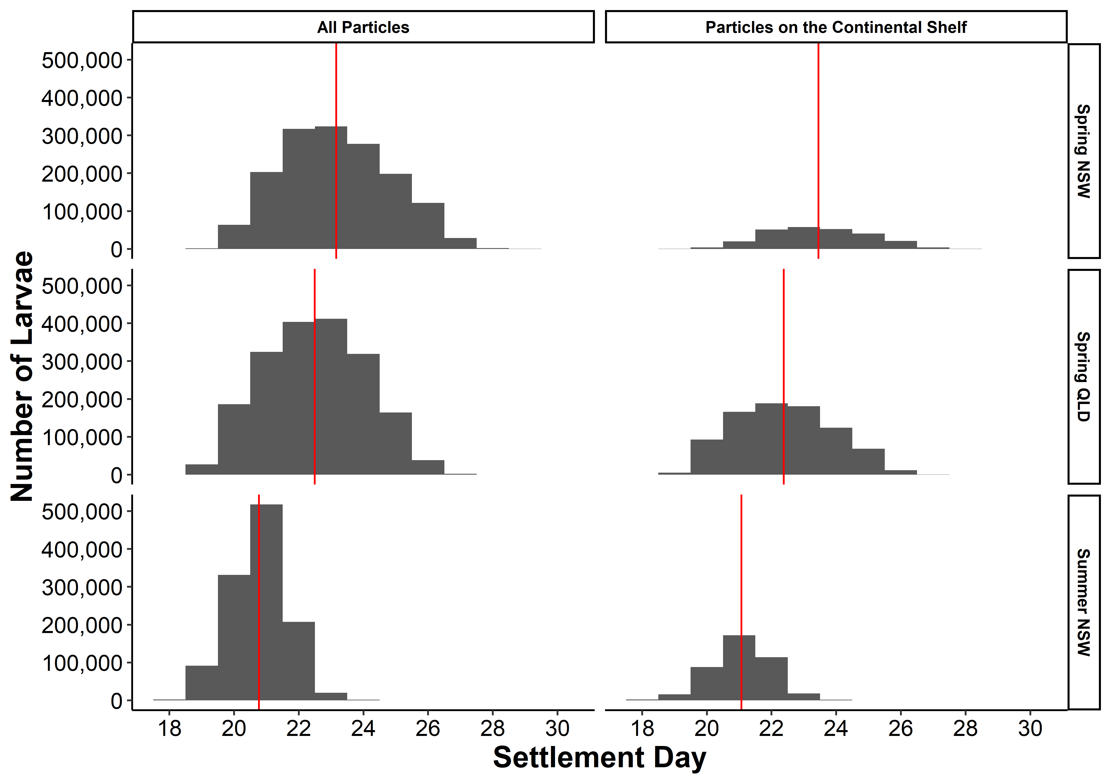

**Figure 2** Histograms showing the settlement times for larvae from the three spawning events, separated into all particles with reached 500 degree days (DD) and particles which were on the continental shelf at 500 DD. The red vertical line represents the mean settlement day for each group of particles.

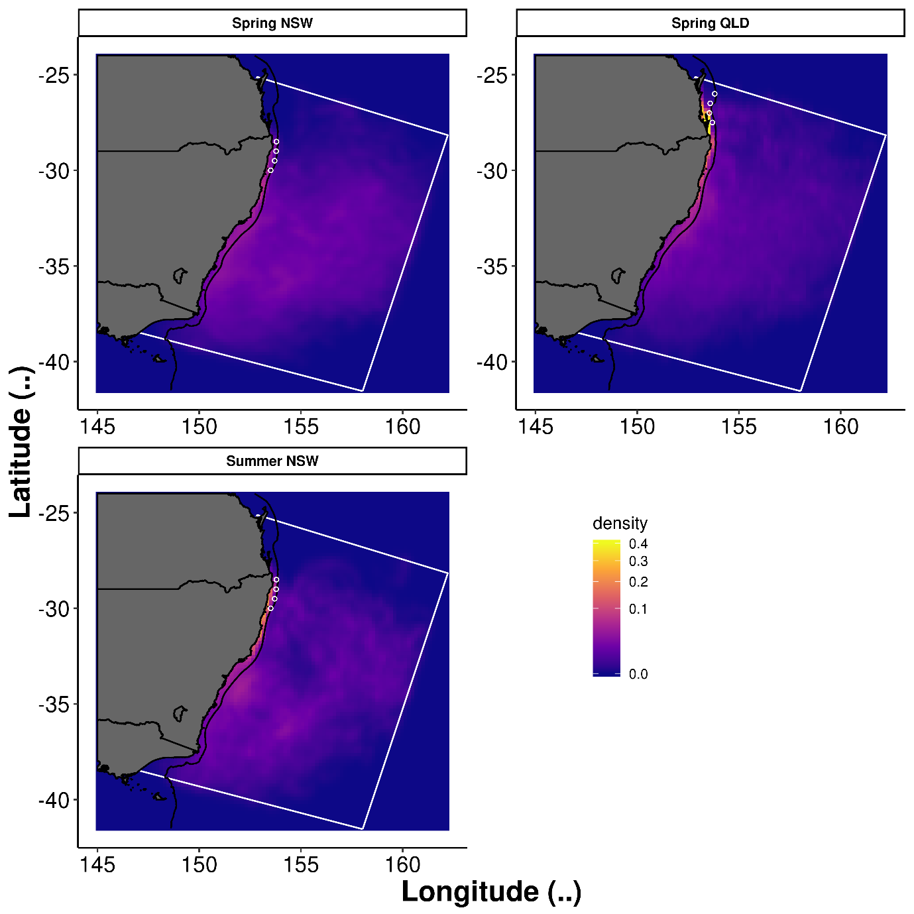

**Figure 3** Density of larvae at settlement time (500 degree days). The open white circles show the release location of the particles for each spawning event. The density colour scale is consistent between subplots but note the non-linear colour scale. Still not sure if the plotting is calculated right, density estimates using Lat/Long may be wrong.

**Figure 4** Percentage of settled larvae (on the continental shelf) at 500 degree days originating from each of the modelled spawning events. Each bar represents the total larvae successfully settled in a 1° latitude bin. Remake to look less like excel plot.

**Figure 5** Backwards tracking of larvae spawned during spring showing the likely spawning locations (500 degree days previously). The density in each subplot is scaled so that the maximum density in each cell is 1. The white box represents the boundary of the regional oceanographic model which provided the velocity fields (Kerry et al., 2016). Need to change labels to names not release Latitude

**Figure 6** Backwards tracking of larvae spawned during late summer showing the likely spawning locations (500 degree days previously). The density in each subplot is scaled so that the maximum density in each cell is 1. The white box represents the boundary of the regional oceanographic model which provided the velocity fields (Kerry et al., 2016). Need to change labels to names not release Latitude

**References**

ANDRELLO, M., MOUILLOT, D., BEUVIER, J., ALBOUY, C., THUILLER, W. & MANEL, S. 2013. Low Connectivity between Mediterranean Marine Protected Areas: A Biophysical Modeling Approach for the Dusky Grouper *Epinephelus marginatus*. *PLOS ONE,* 8**,** e68564.

BRODIE, S., LITHERLAND, L., STEWART, J., SCHILLING, H. T., PEPPERELL, J. G. & SUTHERS, I. M. 2018. Citizen science records describe the distribution and migratory behaviour of a piscivorous predator, *Pomatomus saltatrix*. *ICES Journal of Marine Science,* 75**,** 1573-1582.

CETINA-HEREDIA, P., ROUGHAN, M., LIGGINS, G., COLEMAN, M. A. & JEFFS, A. 2019. Mesoscale circulation determines broad spatio-temporal settlement patterns of lobster. *PLOS ONE,* 14**,** e0211722.

CETINA-HEREDIA, P., ROUGHAN, M., VAN SEBILLE, E. & COLEMAN, M. A. 2014. Long-term trends in the East Australian Current separation latitude and eddy driven transport. *Journal of Geophysical Research. C. Oceans,* 119**,** 4351-4366.

COLEMAN, M. A., ROUGHAN, M., MACDONALD, H. S., CONNELL, S. D., GILLANDERS, B. M., KELAHER, B. P. & STEINBERG, P. D. 2011. Variation in the strength of continental boundary currents determines continent-wide connectivity in kelp. *Journal of Ecology,* 99**,** 1026-1032.

COWEN, R. K., PARIS, C. B. & SRINIVASAN, A. 2006. Scaling of Connectivity in Marine Populations. *Science,* 311**,** 522.

COWEN, R. K. & SPONAUGLE, S. 2009. Larval Dispersal and Marine Population Connectivity. *Annual Review of Marine Science,* 1**,** 443-466.

DAVIES, K. T. A., GENTLEMAN, W. C., DIBACCO, C. & JOHNSON, C. L. 2014. Semi-annual spawning in marine scallops strengthens larval recruitment and connectivity on Georges Bank: a model study. *Marine Ecology Progress Series,* 516**,** 209-227.

DELANDMETER, P. & VAN SEBILLE, E. 2019. The Parcels v2.0 Lagrangian framework: new field interpolation schemes. *Geosci. Model Dev. Discuss.,* 2019**,** 1-24.

DEUEL, D. G., CLARK, J. R. & MANSUETI, A. J. 1966. Description of embryonic and early larval stages of bluefish, *Pomatomus saltatrix*. *Transactions of the American Fisheries Society,* 95**,** 264-271.

EVERETT, J. D., BAIRD, M. E., OKE, P. R. & SUTHERS, I. M. 2012. An avenue of eddies: Quantifying the biophysical properties of mesoscale eddies in the Tasman Sea. *Geophysical Research Letters,* 39**,** n/a-n/a.

EVERETT, J. D., SEBILLE, E., TAYLOR, M. D., SUTHERS, I. M., SETIO, C., CETINA-HEREDIA, P. & SMITH, J. A. 2017. Dispersal of Eastern King Prawn larvae in a western boundary current: New insights from particle tracking. *Fisheries Oceanography,* 26**,** 513-525.

FRASER, C. I., MORRISON, A. K., HOGG, A. M., MACAYA, E. C., VAN SEBILLE, E., RYAN, P. G., PADOVAN, A., JACK, C., VALDIVIA, N. & WATERS, J. M. 2018. Antarctica’s ecological isolation will be broken by storm-driven dispersal and warming. *Nature Climate Change,* 8**,** 704-708.

GALLEGO, A., NORTH, E. W. & PETITGAS, P. 2007. Introduction: status and future of modelling physical-biological interactions during the early life of fishes. *Marine Ecology Progress Series,* 347**,** 121-126.

GREEN, B. S. & FISHER, R. 2004. Temperature influences swimming speed, growth and larval duration in coral reef fish larvae. *Journal of Experimental Marine Biology and Ecology,* 299**,** 115-132.

HARE, J. A. & COWEN, R. K. 1994. Ontogeny and otolith microstructure of bluefish *Pomatomus saltatrix* (Pisces: Pomatomidae). *Marine Biology,* 118**,** 541-550.

HARE, J. A. & COWEN, R. K. 1995. Effect of age, growth rate, and ontogeny on the otolith size – fish size relationship in bluefish, *Pomatomus saltatrix*, and the implications for back-calculation of size in fish early life history stages. *Canadian Journal of Fisheries and Aquatic Sciences,* 52**,** 1909-1922.

HARE, J. A. & COWEN, R. K. 1996. Transport mechanisms of larval and pelagic juvenile bluefish (*Pomatomus saltatrix*) from South Atlantic Bight spawning grounds to Middle Atlantic Bight nursery habitats. *Limnology and Oceanography,* 41**,** 1264-1280.

HARE, J. A. & COWEN, R. K. 1997. Size, growth, development, and survival of the planktonic larvae of *Pomatomus saltatrix* (Pisces: Pomatomidae). *Ecology,* 78**,** 2415-2431.

HINRICHSEN, H.-H., DICKEY-COLLAS, M., HURET, M., PECK, M. A. & VIKEBØ, F. B. 2011. Evaluating the suitability of coupled biophysical models for fishery management. *ICES Journal of Marine Science,* 68**,** 1478-1487.

HOUDE, E. D. 1989a. Comparative growth, mortality, and energetics of marine fish larvae: temperature and implied latitudinal effects. *Fishery Bulletin,* 87**,** 471-495.

HOUDE, E. D. 1989b. Subtleties and episodes in the early life of fishes. *Journal of Fish Biology,* 35**,** 29-38.

JUANES, F., HARE, J. A. & MISKIEWICZ, A. G. 1996. Comparing early life history strategies of *Pomatomus saltatrix*: a global approach. *Marine & Freshwater Research,* 47**,** 365-379.

KERRY, C., POWELL, B., ROUGHAN, M. & OKE, P. 2016. Development and evaluation of a high-resolution reanalysis of the East Australian Current region using the Regional Ocean Modelling System (ROMS 3.4) and Incremental Strong-Constraint 4-Dimensional Variational (IS4D-Var) data assimilation. *Geoscientific Model Development,* 9**,** 3779-3801.

LAMBERT, T. C. & WARE, D. M. 1984. Reproductive strategies of demersal and pelagic spawning fish. *Canadian Journal of Fisheries and Aquatic Sciences,* 41**,** 1565-1569.

LANGE, M. & VAN SEBILLE, E. 2017. Parcels v0.9: prototyping a Lagrangian ocean analysis framework for the petascale age. *Geoscientific Model Development,* 10**,** 4175-4186.

LEIGH, G. M., O'NEILL, M. F. & STEWART, J. 2017. Stock assessment of the Australian east coast tailor (*Pomatomus saltatrix*) fishery. Brisbane: Queensland Department of Agriculture and Fisheries.

LITHERLAND, L., ANDREWS, J., STEWART, J. & LEWIS, P. 2016. Tailor *Pomatomus saltatrix*. *In:* STEWARDSON, C., ANDREWS, J., ASHBY, C., HADDON, M., HARTMANN, K., HONE, P., HORVAT, P., MAYFIELD, S., ROELOFS, A., SAINSBURY, K., SAUNDERS, T., STEWART, J., STOBUTZKI, I. & WISE, B. (eds.) *Status of Australian fish stocks reports 2016.* Canberra: Fisheries Research and Development Corporation.

MISKIEWICZ, A. G., BRUCE, B. D. & DIXON, P. 1996. Distribution of tailor (*Pomatomus saltatrix*) larvae along the coast of New South Wales, Australia. *Marine and Freshwater Research,* 47**,** 331-336.

MUNROE, D. M., HAIDVOGEL, D., CARACAPPA, J. C., KLINCK, J. M., POWELL, E. N., HOFMANN, E. E., SHANK, B. V. & HART, D. R. 2018. Modeling larval dispersal and connectivity for Atlantic sea scallop (*Placopecten magellanicus*) in the Middle Atlantic Bight. *Fisheries Research,* 208**,** 7-15.

NEIRA, F. J., MISKIEWICZ, A. G. & TRNSKI, T. 1998. *Larvae of temperate Australian fishes: laboratory guide for larval fish identification*, UWA Publishing.

NEUHEIMER, A. B. & TAGGART, C. T. 2007. The growing degree-day and fish size-at-age: the overlooked metric. *Canadian Journal of Fisheries and Aquatic Sciences,* 64**,** 375-385.

NOLASCO, R., GOMES, I., PETEIRO, L., ALBUQUERQUE, R., LUNA, T., DUBERT, J., SWEARER, S. E. & QUEIROGA, H. 2018. Independent estimates of marine population connectivity are more concordant when accounting for uncertainties in larval origins. *Scientific Reports,* 8**,** 2641.

OKE, P. R., SAKOV, P., CAHILL, M. L., DUNN, J. R., FIEDLER, R., GRIFFIN, D. A., MANSBRIDGE, J. V., RIDGWAY, K. R. & SCHILLER, A. 2013. Towards a dynamically balanced eddy-resolving ocean reanalysis: BRAN3. *Ocean Modelling,* 67**,** 52-70.

PARIS, C. B., COWEN, R. K., CLARO, R. & LINDEMAN, K. C. 2005. Larval transport pathways from Cuban snapper (Lutjanidae) spawning aggregations based on biophysical modeling. *Marine Ecology Progress Series,* 296**,** 93-106.

PEPIN, P. 1989. Predation and Starvation of Larval Fish: A Numerical Experiment of Size- and Growth-Dependent Survival. *Biological Oceanography,* 6**,** 23-44.

POLLOCK, B. R. 1984. The tailor (*Pomatomus saltatrix*) fishery at Fraser Island and its relation to the life-history of the fish. *Proceedings of the Royal Society of Queensland,* 95**,** 23 - 28.

SANTOS, A. M. P., NIEBLAS, A. E., VERLEY, P., TELES-MACHADO, A., BONHOMMEAU, S., LETT, C., GARRIDO, S. & PELIZ, A. 2018. Sardine (*Sardina pilchardus*) larval dispersal in the Iberian upwelling system, using coupled biophysical techniques. *Progress in Oceanography,* 162**,** 83-97.

SCHILLING, H. T. 2019. *Ecology of tailor, Pomatomus saltatrix, in eastern Australia.* PhD PhD Thesis, University of New South Wales.

SCHILLING, H. T., REIS-SANTOS, P., HUGHES, J. M., SMITH, J. A., EVERETT, J. D., STEWART, J., GILLANDERS, B. M. & SUTHERS, I. M. 2018. Evaluating estuarine nursery use and life history patterns of *Pomatomus saltatrix* in eastern Australia. *Marine Ecology Progress Series,* 598**,** 187-199.

SCHILLING, H. T., SMITH, J. A., STEWART, J., EVERETT, J. D., HUGHES, J. M. & SUTHERS, I. M. 2019. Reduced exploitation is associated with an altered sex ratio and larger length at maturity in southwest Pacific (east Australian) *Pomatomus saltatrix*. *Marine Environmental Research,* 147**,** 72-79.

SIEGEL, D. A., MITARAI, S., COSTELLO, C. J., GAINES, S. D., KENDALL, B. E., WARNER, R. R. & WINTERS, K. B. 2008. The stochastic nature of larval connectivity among nearshore marine populations. *Proceedings of the National Academy of Sciences,* 105**,** 8974-8979.

SUN, C., FENG, M., MATEAR, R. J., CHAMBERLAIN, M. A., CRAIG, P., RIDGWAY, K. R. & SCHILLER, A. 2012. Marine Downscaling of a Future Climate Scenario for Australian Boundary Currents. *Journal of Climate,* 25**,** 2947-2962.

SUTHERS, I. M., YOUNG, J. W., BAIRD, M. E., ROUGHAN, M., EVERETT, J. D., BRASSINGTON, G. B., BYRNE, M., CONDIE, S. A., HARTOG, J. R., HASSLER, C. S., HOBDAY, A. J., HOLBROOK, N. J., MALCOLM, H. A., OKE, P. R., THOMPSON, P. A. & RIDGWAY, K. 2011. The strengthening East Australian Current, its eddies and biological effects — an introduction and overview. *Deep Sea Research Part II: Topical Studies in Oceanography,* 58**,** 538-546.

VERGÉS, A., STEINBERG, P. D., HAY, M. E., POORE, A. G. B., CAMPBELL, A. H., BALLESTEROS, E., HECK, K. L., BOOTH, D. J., COLEMAN, M. A., FEARY, D. A., FIGUEIRA, W., LANGLOIS, T., MARZINELLI, E. M., MIZEREK, T., MUMBY, P. J., NAKAMURA, Y., ROUGHAN, M., VAN SEBILLE, E., GUPTA, A. S., SMALE, D. A., TOMAS, F., WERNBERG, T. & WILSON, S. K. 2014. The tropicalization of temperate marine ecosystems: climate-mediated changes in herbivory and community phase shifts. *Proceedings of the Royal Society B: Biological Sciences,* 281.

ZELLER, B. M., POLLOCK, B. R. & WILLIAMS, L. E. 1996. Aspects of the life history and management of tailor (*Pomatomus saltatrix*) in Queensland. *Marine & Freshwater Research,* 47**,** 323-329.